姓名 __________________ 班级 ____________ 日期 _________________
吃 |  | to eat 6 |  |  |  |  |  |  |  |  |  |  | 菜 | 菜 | vegetable; dish (of vegetable) 11
 |  | 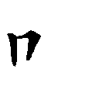 |  |  |  | 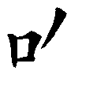 |  | 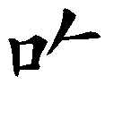 |  | 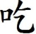 |  |  |  |  |  |  |  | 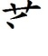 | 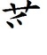 | 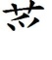 | 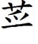
 |  |  |  |  |  |  |  |  |  |  |  |  |  | 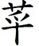 | 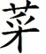 |  | 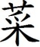
chī | Radical: 口 mouth |  |  |  |  |  |  |  |  |  |  |  | cài | Radical: 艹(草) grass
好 |  |  | thirsty 12 |  |  |  |  |  |  |  |  |  | 饭 | 飯 |  | meal; cooked rice 7
 |  |  | 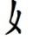 | 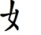 | 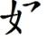 |  | 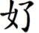 |  | 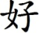 |  |  |  |  |  |  | 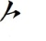 | 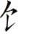 | 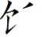 | 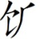 | 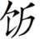 | 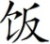
hǎo | Radical: 女girl; lady; female |  |  |  |  |  |  |  |  |  |  |  | fàn | Radical: 饣(食) food

diǎn | héng | shù | piě | nà |  | chī | cài | fàn | hǎo
丶 | 一 | 丨 |  |  | 吃 | 吃 | 菜 | 饭 | 好
diǎn | héng | shù | piě | nà |  | chī | cài | fàn | hǎo
丶 | 一 | 丨 |  |  |  | 吃 | 菜 | 饭 | 好
Worksheet 1

